Table of Contents
Introduction 3
1.1 Plan to Address Objectives 3
1.2 Project scope 4
1.2.1 Information scope 4
1.2.2 Functional scope 5
1.2.3 Communication scope 5
1.3 Business requirements 5
1.4 Hardware and Software Requirements 6
1.4.1 Software Requirements 6
1.4.2 Hardware Requirements 7
1.5 Design constraints 8
1.5.1 Security constraints 8
1.5.2 Interface constraints 8
1.5.3 Performance constraints 9
1.6 High-level use case diagram 10
1.7 UML Class Model / Diagram 11
Association 12
Aggregation 12
Composition 13
Inheritance 13
Multiplicity 14
Unused logic connections 14
1.8 Relational Database Model Diagram 15
One-to-One 15
One-to-Many 16
Many-to-Many 16
1.9 User Interface Design 17
Login Screen: 17
Sign Up Screen 18
Register a Business 19
Client Home screen 20
Client Menu Screen 21
The “+” Button 22
Client Marketplace Screen 23
Client Profile 24
Business Owner Home screen 25
Business Owner Menu Screen 26
The Business Owner “+” Button 27
Business Owner Marketplace 28
1.10 Annexure 29

Introduction

This document, titled System Requirements, Specifications and Technical Design, is an architectural view for SplashScreen, a mobile application developed by The Ripple Effect. Following our blueprint, the Business Case, and the Software Development Life Cycle, we now enter the designing stage of this application, translating the identified objectives into functional project requirements.

The three key primary sections covered in this document are: the project objectives, business and system requirements and the holistic design of SplashScreen. This document provides a detailed breakdown of the project’s scope through conceptual models that include a UML diagram and a database model. By formalizing these specifications, this document ensures that our development process is aligned with a clear and feasible plan, thereby providing a definitive reference for the ongoing development and future iterations of the SplashScreen.

1.1 Plan to Address Objectives

In our business case, we dissected our identified problem of pool maintenance into different sub-problems that were categorized based on the user that they affected.
For the individual pool owner these are:
- Uneducated pool care often leads to wasting resources such as water.
- Manual record-keeping is tedious and time-consuming.
- Securing a trustable service provider that completes the required task is difficult in a fragmented market.
For pool service providers these are:
- Managing clients is often a disjointed task requiring multiple applications to complete a single workflow.
- Expanding as a professional entity can be difficult if the correct clients are not approached in the correct manner.

SplashScreen is an android application that aims to simplify pool maintenance. By giving our new users a guided walkthrough of both how to use the app and general insights on pool maintenance, we solve the issue of uneducated pool care. This will be in the form of walkthrough screens, similar to tutorials and video resources found online.

Our system will offer users the ability to move away from manual record-keeping through a personalized pool input and calculator system. This system will be enhanced with real-time data collected from various application programming interfaces sources such as the local weather, municipality water restriction feed and the load shedding timeline to equip pool owners and service providers with verified information to make informed decisions.

The marketplace serves as a two-way link between the service provider and the service consumer. While individuals are not required to request a service or buy a product from a marketplace business, SplashScreen, gives them a direct verified link to the source. When businesses request registration for a business account, our team will first verify their legitimacy as well as allocate a non-biased review based on current public company data. Once verified and registered, a business will be able to search through the client pool in the form of current individuals on the platform who agreed to have their profile public. This approach solves both the sub-problems of an unverified marketplace for pool owners and the difficulty of attaining clients for service providers.

Another major issue we identified is the disjointed task of managing clients for service providers. We define this as the requirement of multiple avenues to complete a single client job:
- First securing a client through a communication channel.
- Logging the required services for the respective pool of the client.
- Generating a report on the history of services provided.

This is multiplied by several clients which can be inefficient to continue executing. SplashScreen’s marketplace allows businesses to sift through the general public towards their target market. They can then leave notes for the client based on services provided. This will generate an automatic history report on the previous operations.

1.2 Project scope

1.2.1 Information scope

The Pool owner’s information will be stored in a centralized Firebase Firestore database, organized across different tables within the system. Sensitive data, such as their password will be encrypted through Firebase authentication services to ensure data privacy and protection. Non-sensitive information, such as pool details and maintenance records, will be stored and saved without encryption as these entities do not reveal personal information. This will balance security, performance and data management more efficiently while ensuring that sensitive user information remains secure.

Pool owners:
- Login details, such as their email address, password and their home address for client’s wanting to employ someone to take care of their pool.
- Pool details, such as pH levels, pool capacity, chlorine amount and pool size.

Service Provider’s information will be stored in the same centralized database but organized into separate tables for improved data management. Their login details and their password will be securely encrypted through Firebase authentication services to ensure data privacy and protection. Additional data, such as client information, will be stored in linked tables, ensuring proper relational structure while preventing unauthorized access to the information. This will ensure that all sensitive personal data remains protected, while operational data is managed properly without the risk of exposure to the wrong parties.

Service provider:
- Login details, such as their email address and password.
- Booking details
- Service on pool notes

1.2.2 Functional scope

To address the problem statement and the objectives, SplashScreen will have multiple features that will follow a microservice architecture. This development style will ensure we build to scale while managing our system services efficiently with modularity in mind. Our projected functions for our minimum viable product include:
- Pool Owners:

- Register and manage multiple pools.
- Record water quality measurements.
- Receive alerts for chemical maintenance, load shedding, and municipal restrictions.
- Schedule professional service bookings.
- Purchase chemicals and equipment directly from providers.

- Service Providers:

- Create profiles and list services offered.
- Manage bookings and product sales.
- Receive customer reviews and ratings.

- System Features:

- Centralised notifications and reminders.
- Integration with weather and load-shedding APIs.
- Compliance tracking with municipal water restrictions.
- Pool maintenance recommendation system
- Marketplace to connect Pool owners and Service Providers

1.2.3 Communication scope

Pool owners will be notified on the SplashScreen app for guidance or notes on how the app works. Any updates to their information or notes will be notified with a pop-up notification on the screen that the information has been updated and synced to their database. Connection to the internet will allow the pool owners to communicate with the service provider to help book someone to take care of their pools or for some assistance.

1.3 Business requirements

Business requirements, stakeholder requirements specifications, defines the characteristics and expectations of a proposed system from the perspective of the system's end users. For SplashScreen, there are two primary user types: pool owners and service providers. Each of the user types has specific needs that the system must address to ensure usability, reliability, and value.

Pool Owners:
The pool owners require a system that:

- Helps pool owners maintain their pools by suggesting the right chemical dosages, setting up maintenance schedules, and sending reminders to reduce mistakes.
- Keeps pool and maintenance data safe, making it easy for users to store and find records like water readings, maintenance tasks, and notes.
- Makes it simple for users to navigate dashboards, log water readings, book services, and view reports without any confusion.
- Supports offline operation making it possible for the user to still use the during loadshedding or in areas with poor or no network access. The app allows offline data entry and synchronizes when connectivity resumes.
- Ensures a transparent marketplace for pool owners to access a vetted list of local service providers and products, with clear pricing and availability.
- Provides push notifications for maintenance reminders, service confirmations, municipal water restrictions, or alerts for loadshedding.

Service Providers:
Service providers require a system that:

- Effectively manages bookings so that providers should be able to view, accept, or decline appointments and track service history.
- Displays product and service information clearly which allows providers to manage their services they offer, pricing, and availability.
- Promotes communication with clients by allowing providers to update clients on bookings, service progress, or issues through messaging or notifications.
- Supports administrative functionality by having dashboards to view revenue summaries, service trends, and client feedback.
- Ensures security and access control so only authorized personnel can access sensitive client data, and role-based permissions must be enforced.

1.4 Hardware and Software Requirements

1.4.1 Software Requirements

- Development

- Development Environment: The mobile application will be developed using Android Studio.
- Development Tools: Java 11 will be utilized for building the system functionality and XML for system design.
- System Database: The application's backend services, including user authentication and the shared online database, will be provided by Google Firebase.
- System Software: SplashScreen is compiled with Android SDK 35.

- Production usage

- Operating System: SplashScreen requires a device with an operating system of Android 11 or higher.
- Specifically, SplashScreen requires a minimum API level of 30, Android 11, also known as R.

1.4.2 Hardware Requirements

- Development

- Internal build: Android Studio, our development environment requires the following to operate efficiently:
- Display: Minimum of 1280 x 800 screen resolution for Desktop devices.
- Processor (CPU): Multi-core processor with x86_64 architecture that has virtualization support.
- Memory (RAM): A minimum of 16 GBs of RAM.
- Physical Storage: While 8 GB for the IDE and Android SDK will meet the entry requirements, an SSD with 16 GBs of space or more is recommended.
- Internet Connection: Stable internet connection is a necessity as we debug and test our database queries.

- Production usage

- Display: We built our app for modern smartphone resolutions, specifically those with an aspect ratio of 16:9 or 19.5:9. While it will scale to other screens, SplashScreen is designed for a typical phone resolution of 1080 x 1920 pixels (Full HD).
- Processor (CPU): A multi-core processor is recommended for smooth performance, especially when handling our UI animations and network requests.
- Memory (RAM): The application's minimum requirement is 2 GB of RAM, though 4 GB or more is recommended.
- Physical Storage: The downloadable .apk file will be approximately 50MB in size but it will require additional storage for cached data from Firebase database. A minimum of 200 MB of free storage is recommended.
- Internet Connection: SplashScreen requires a stable internet connection (Wi-Fi or mobile data) to perform authentication and access data from the Firebase backend.

1.5 Design constraints

1.5.1 Security constraints

- Sensitive Information: Handling Personally Identifiable Information like user names, addresses, and contact details requires confidentiality. If this data is stored or processed without proper protection, it could lead to severe privacy breaches.
All sensitive user information from login credentials to user’s home address, will be secured using recommend encryption methods. This means that data is the unreadable. Whether it's stored on user’s mobile device or safely on our server, the personal details should remain private and protected from unauthorized access.
- Authentication and Recovery: In the digital age, the CIA triad (confidentiality, integrity and availability) is being compromised every day. One of those pillars, confidentiality, is defined as the verified access to systems accounts and information by authorized users. Establishing and maintaining trust hinges on strong user authentication. User authentication is enforced through secure login credentials with password hashing. A password recovery feature is also available via registered email addresses; this will ensure that forgotten credentials do not compromise system access.
- Transactions: Financial transactions present a high-risk security threat that can be exploited by malicious parties if not handled securely. There any form of payment is not stored within the system rather are handled by service providers and their trusted medium of financial transaction. This transfers financial risk while ensuring compliance with industry security standards.

1.5.2 Interface constraints

- Screen Size: An evident limitation is screen size. As SplashScreen is a mobile application, we will be constrained to a small number of elements on a screen, increasing the number of screens needed.
- User technical expertise: A large demographic of our main target market, pool owners, is the older population. These users often have limited technical skills. SplashScreen’s mobile application interface should be simple enough to cater towards this group of users who are not as tech-savvy.
- Navigation complexity: Navigation is a key factor to enhance when creating any system. We found that any mobile application with a complex navigation system often spawns from the lack of understanding the targeted user interface. Our mobile application is not only limited to a number of elements based on screen real estate but also the general practices and principles that make a good mobile app navigation system,
- Standard User experience: The user experience across different android applications can often feel different. While hardware specifications are a factor to consider, SplashScreen strives to create a standard, enjoyable user experience across our targeted android device range, ensuring every tap and scroll remains responsive.
- User Journey complexity: Something so crucial is often disregarded over app development and features. Our system also has a built-in tutorial/walkthrough to demonstrate how the application works. This will guide first-time users through key features such as logging pool data, booking services, and managing notifications.

1.5.3 Performance constraints

- Limited computing resources: While modern day smartphones are becoming more sophisticated in nature, arguably most users will be using a system that will not handle unoptimized computing. We are building our system to perform optimally on low-end mobile devices with limited memory and processing power, as not all users have access to high-end devices.
- Internet connectivity: Smartphones are not always connected to the internet, and at times when they are, the network connection may be instable such 3G connectivity. Needless to say, offline functionality is an essential part of the mobile app experience. SplashScreen will allow data entry, like logging water readings, without connectivity and will sync efficiently once a stable internet connection is available.
- Battery consumption: Unlike their desktop counterparts, mobile devices such as laptops and phones are not always connected to a power source. This presents the next constraint: the battery consumption model. SplashScreen should be optimized to minimize power usage while allowing the user to complete their required operations.

1.6 High-level use case diagram

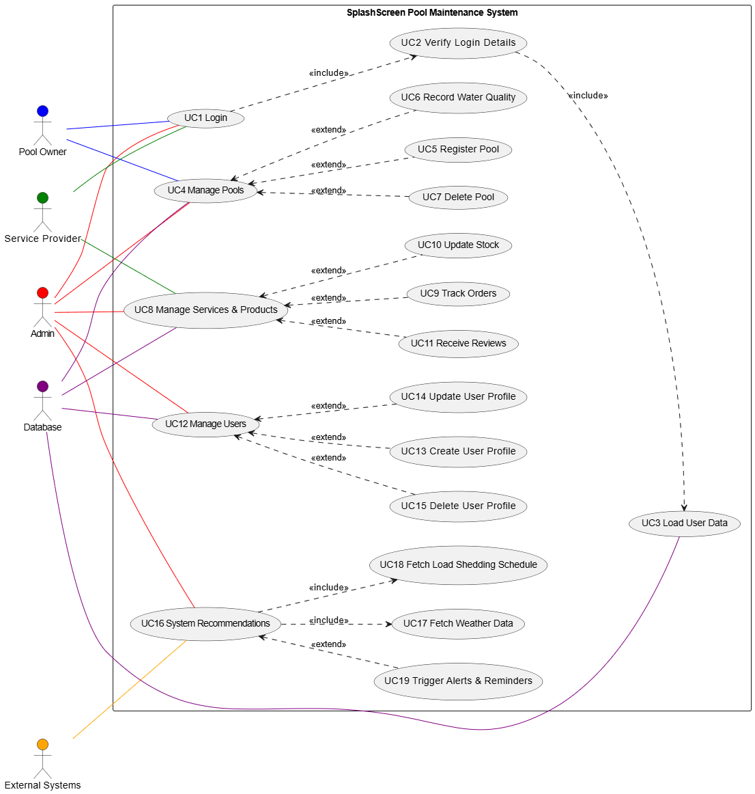

Figure 1.1 High-level use case diagram
Figure 1.1 presents a high-level use case diagram of SplashScreen’s pool maintenance system providing the different actors connected to the system’s use cases.

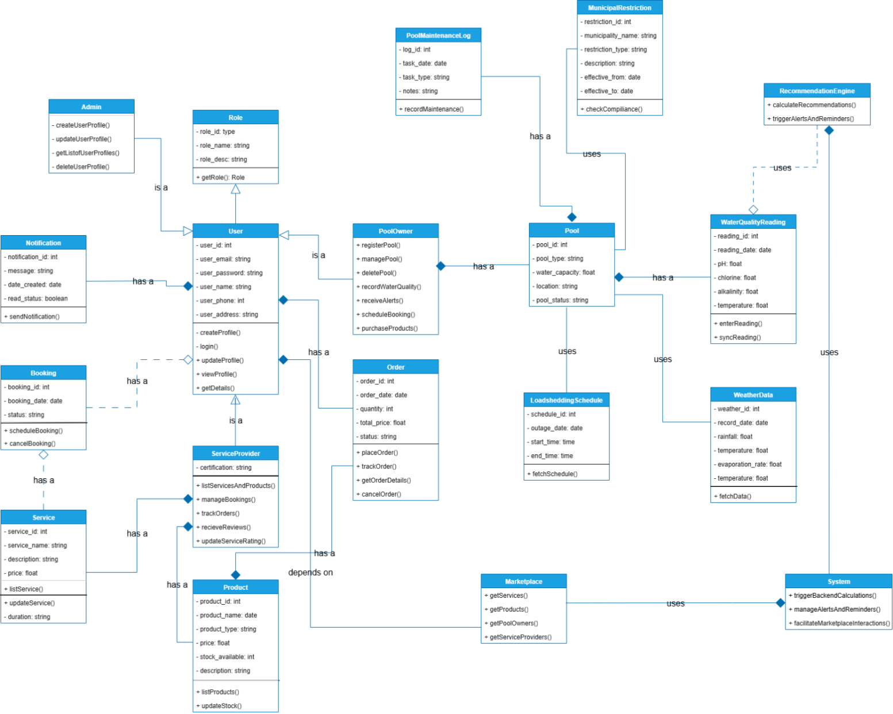
1.7 UML Class Model / Diagram
Figure 1.2 Unified Modelling Language class diagram

SplashScreen’s anatomy is constructed based on the Figure 1.2, the Unified Modelling Language (UML) class diagram. From a high-level view, most class properties are declared private (-) for system security measures, limiting unintentional access and modification of fields whilst the class methods are public (+) offering the functionality required to interact with the classes. Our system presents different logical connections between classes, viewed as relationships. The different relationships present in our UML are:

Association
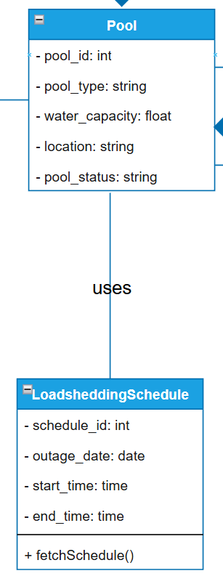
Figure 1.3 Connection between Pool and Load shedding schedule

As the weakest relationship, association is the bonding of two classes without direct ownership. Figure 1.3 shows the connection between the Pool and the Load shedding schedule classes. While a pool utilizes the data gathered from the Load shedding API, it is not strictly bound to this data source. Both classes can function independently without the existence of the other class. This creates a weak has-a connection where a pool has, or more specifically: is associated with, a load shedding schedule but is not entirely dependent on it to operate. We have used the keyword “uses” to differentiate this from the aggregation relationship.

Aggregation


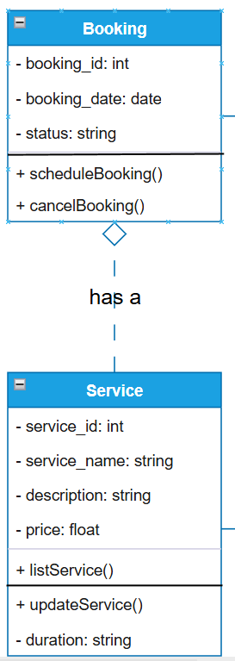
Figure 1.4 Connection between Booking and Service Figure 1.5 Aggregation Connection

Where two classes have an occurrence of weak ownership, aggregation occurs. In our given example, Figure 1.4, the Booking class is related to the Service class as Bookings are based on the available services but this is weak as if a booking is cancelled, the service still exists. A service provider may stop rendering a particular service thus deleting the service but the previous bookings for that service will still exist, maintaining a record history. This relationship presents a moderate has-a connection, where a booking has, is aggregated by, a service.

Composition

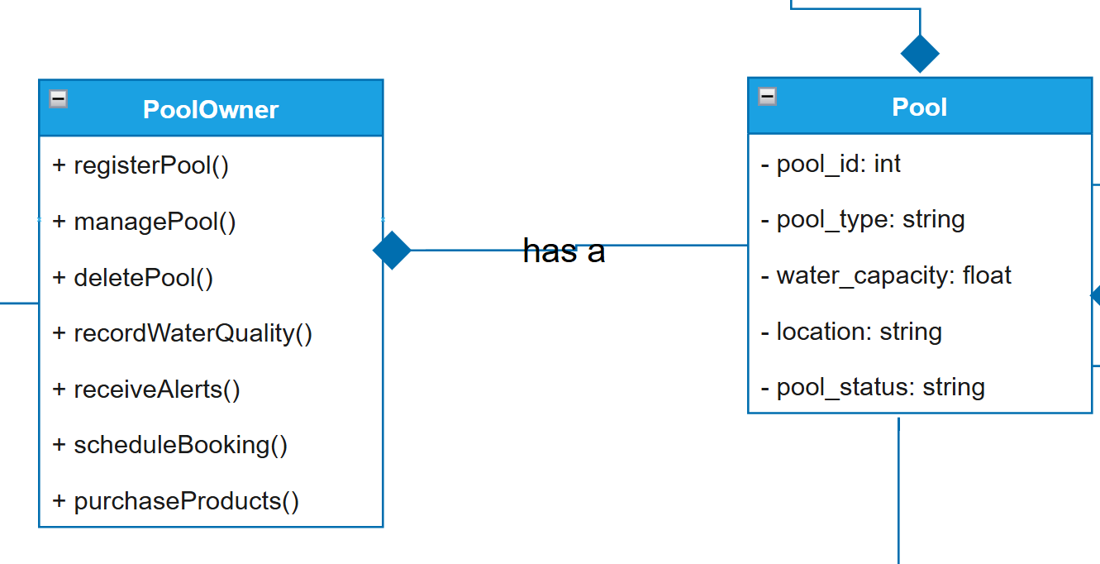
Figure 1.6 Connection between Pool owner and pool Figure 1.7 Composition connection

Composition follows the has-a logical connection structure with a stronger explicit ownership-based relationship between two classes. A pool is owned by a specific pool owner, thus if their account is deleted, all pools and their respective data such as maintenance logs, and water quality readings should also be destroyed systematically. This structure creates a concrete bond between classes that would fail to function without the classes that they depend on.

Inheritance
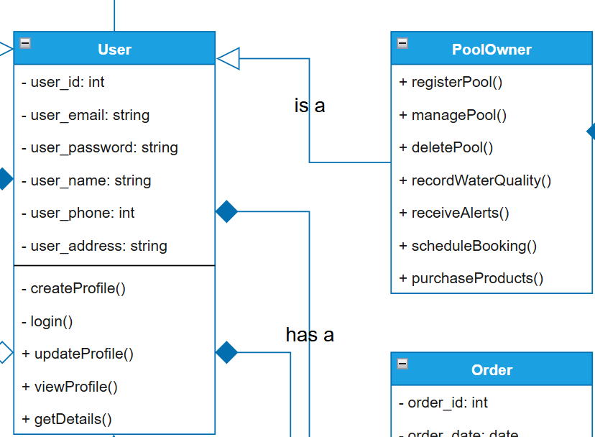

Figure 1.8 Connection between User and pool owner Figure 1.9 Inheritance connection

Figure 1.8 illustrates an instance of inheritance, the concept of a class being a specific child-class of another class. As a pool owner is a specific type of user, they gain all the properties and methods assigned to the user class along with pool owner specific methods such as registering and managing pools. This object orientated principle allows for modular code that does not duplicate common properties and methods amongst the three user types: pool owners, service providers and the admin while also offering the ability to extend these subclasses for class-specific functionality. Our UML class diagram for SplashScreen demonstrates an is-a relationship between a pool owner and the user class.

Multiplicity

Multiplicity is the number of instances of a specific class that can be related to an instance of a different class, also known as cardinality. This quantitative relationship can be in the form of one-one, one-to-many and man-to-many, usually represented as 1..1, 0..*, *..* in a UML.

Unused logic connections

Reflexive Association occurs when a class has a relationship with itself, a user may be a referrer for another user. This connection is not present in our current UML class diagram as it would be redundant

Realization is the concept of a class implementing an interface. While we could create an ISchedulable interface that is implemented by both the Booking and the Service class to abstract the scheduling functionality but since these are concrete classes, there is no need to add this redundant behavior.

1.8 Relational Database Model Diagram
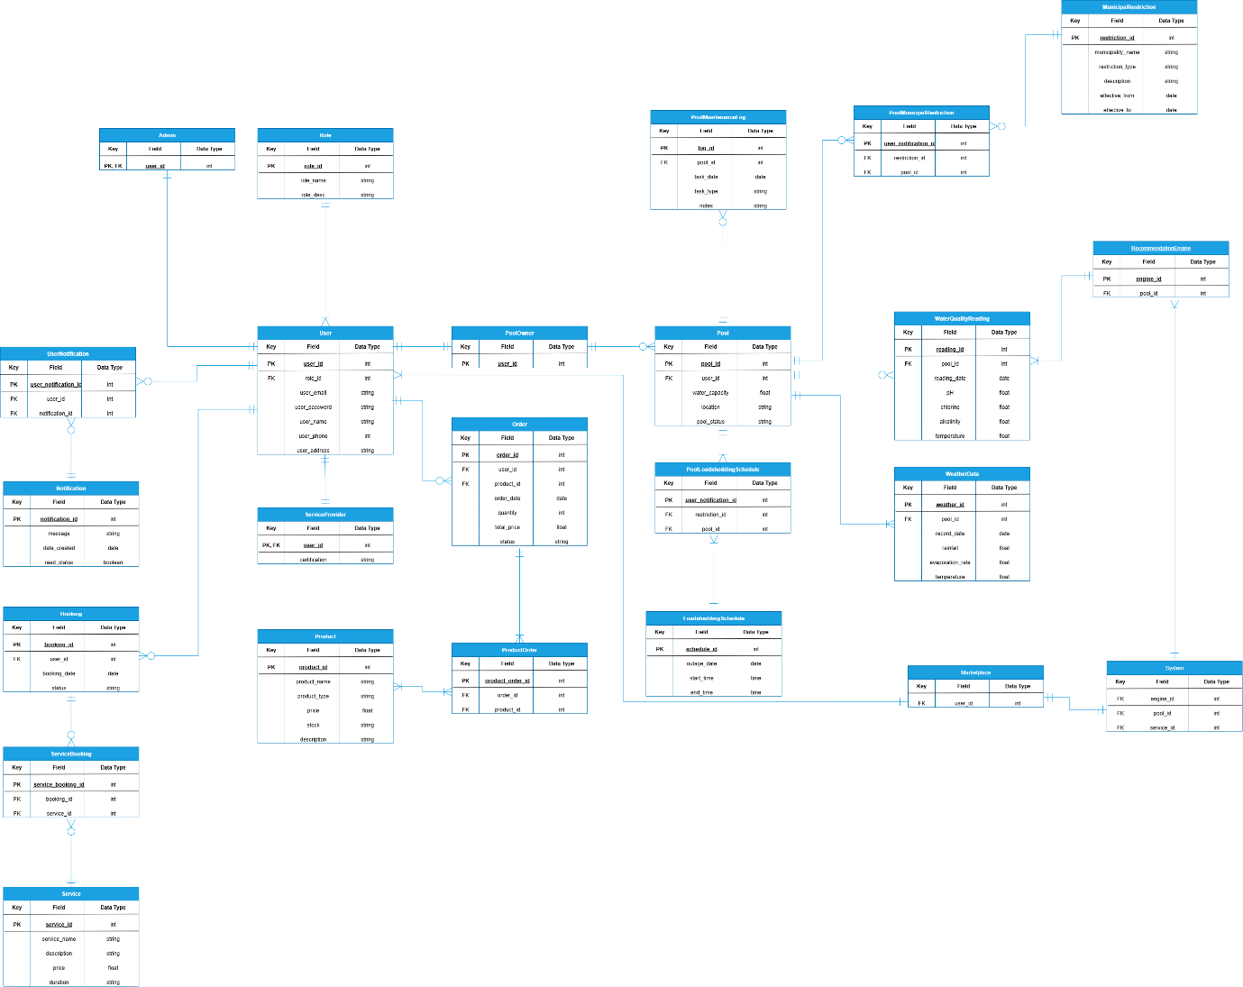
Figure 1.10 Entity Relational Diagram

The Entity Relational Diagram (ERD) above represents the physical connection of the SplashScreen database. Building on the UML class diagram, this illustration models the different entity relationships, one-to-one, one-to-many and many-to-many, viewed as multiplicity in our UML class diagram. We analyze how our data is stored and how it will interact with different components:

One-to-One

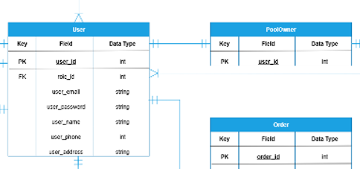

Figure 1.12 One-to-one relationship
Figure 1.11 Relationship between User and Pool owner

This physical connection occurs when one entity such as pool owner only has only one relational mapping to another entity, user. As we explained in our UML class diagram, a pool owner can only have one account under that specific User account with the related inherited information thus this physical connection was used based on inheritance. Another instance is the relationship between the system and the marketplace. The system utilizes marketplace data. This model is also an example of the Singleton design pattern.

One-to-Many

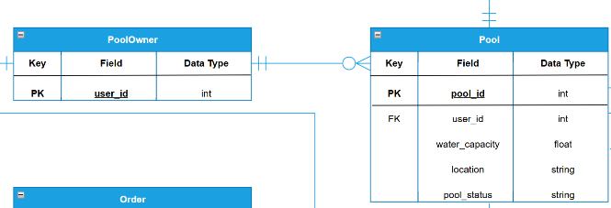

Figure 1.14 One-to-many relationship

Figure 1.13 Relationship between Pool owner and pool

A one-to-many connection is defined as a single entity, such as pool owner, being linked to multiple entries of another entity, such as pool. This is implemented through adding the primary key of the single entity to another entity, which becomes a foreign key, allowing the database to distinguish which entry in the table belongs to which single entity. This physical connection corresponds to our association and aggregation logical connection types in the UML class diagram. Figure 1.13 shows that a pool owner can have zero or more pools but in strict instances, we implemented Figure 1.14 where an entity on the owning side has to own one or more of the owned entities.

Many-to-Many

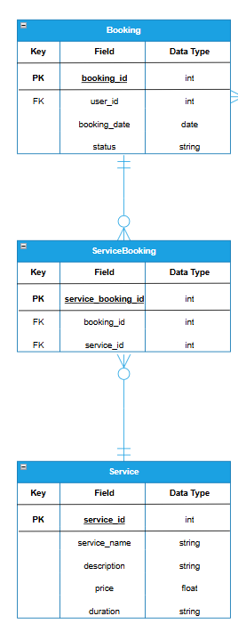
Figure 1.15 Relationship between Booking and Service

As per our database design, sometimes it is required to link multiple entries from one table to multiple entries in another table. This cannot be implemented directly rather we create a junction table, also known as an associative entity, that holds the primary key of the related entities as foreign keys. Figure 1.15 shows how a single booking can have multiple services while a single service can be contained in multiple bookings, thus we introduce a ServiceBooking table. This entity serves as the intermediary link that allows the database to uniquely identify service bookings based on this many-to-many model.

1.9 User Interface Design

Login Screen:

The Login Screen provides secure authentication for both pool owners and service providers. Its functionality ensures that only registered users can access the system.
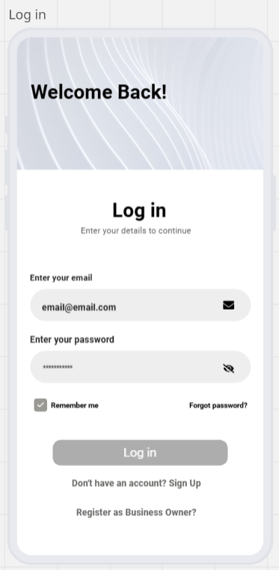
- Email Input Field:
  - Requires the user to enter their registered email address.
- Password Input Field:
  - Requires the user to enter their password securely.
  - It also includes a visibility toggle icon, eye icon, to show or hide the password for ease of use.
  - All users’ passwords are encrypted to protect user data.
  - Password Strength will be tested against industry standards.
- Remember Me Tick Box:
  - The user can select whether the system securely stores login credentials on the device to allow faster login in future sessions.
- “Forgot Password” Link:
  - This link provides users, who have forgotten their password, a way for them to reset it.
  - By clicking on the link, it redirects the user to the password recovery process, which is completed via using their registered email.
- Log in Button:
  - After the user have entered their details they click the log in button, it authenticates the provided email and password against the database.
  - If the credentials are correct, it grants access to the system.
Figure 2.1 Login Screen
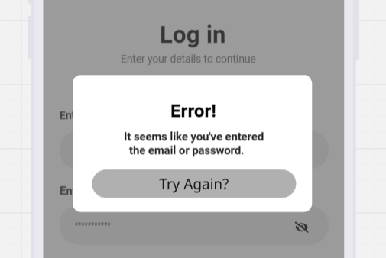
  - Displays an error message if login fails due to incorrect details or unregistered accounts. (Figure 4)
- Sign Up Option:
  - If the user is new, they have an option to click on this link to create an account if they do not already have one.
- Register as Business Owner Option:
  - This link allows service providers to register specifically as business accounts.
  - This ensures they receive role-specific functionality such as service management and client bookings.
Figure 2.2 Error Message

Sign Up Screen
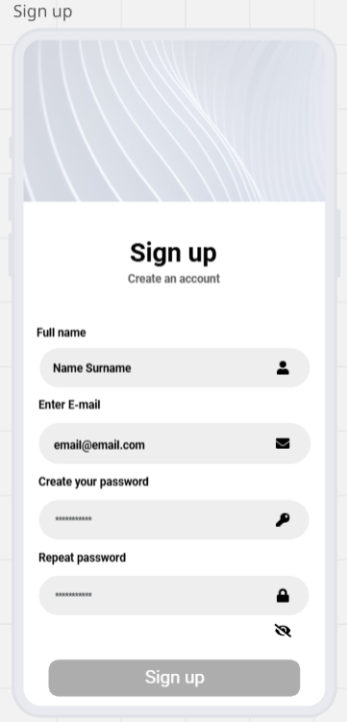
The Sign-Up Screen allows new users to register an account in the SplashScreen system.

- Name Input Field:
  - The user is asked to enter their full name for identification within the system.
- Email Input Field:
  - Asks the user’s email address, which serves as their unique identifier for login, which will prevent the making of duplicate accounts.
- Create Password Field:
  - Requires the user to create a secure password for their account.
- Repeat Password Field:
  - Ensures that the password is confirmed by requiring the user to re-enter it.
  - Includes validation to check that the two passwords match before submission.
- Sign Up Button:
  - Submits the entered data to the database after validation.
  - If all details are valid, a new user profile is created in the Firestore database.
  - If there are errors, like mismatched passwords or existing email, an error message is displayed.
  - On successful registration, the user is redirected to the Login Screen to access their account.

Figure 2.3 Sign Up Screen

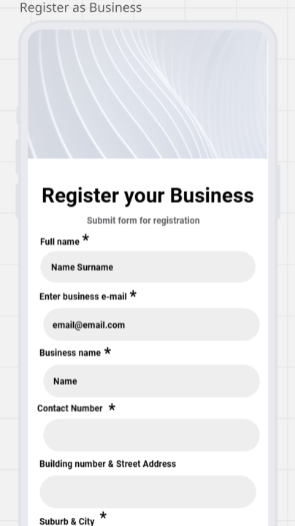
Register a Business

This screen follows when the user clicks on the “Register as Business Owner?” link on the Login screen. It allows service providers, like pool maintenance companies or independent entrepreneurs, to create a business account in the SplashScreen application. This registration process ensures that providers are onboarded with the necessary details to appear in the service marketplace and manage client bookings. Forms are accepted or declined by developers to ensure only legitimate businesses are given access to advertise and manage their business on our app. This process prevents misuse of the platform by individuals posing as businesses.

- Full Name
- Captures the business owner’s name.
- Business Email Address
- Email entered is used for official communication and verification.
- Business Name
- The registered name of the business.
- Contact Number
- Allows clients and the platform to reach the business.
- Also used for communication and verification.
- Address Details
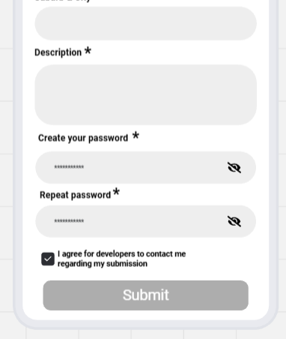
- To verify whether they have an official store and where it is located.
Figure 2.4 – Business Registration Screen
- Description
- Short description of the business and what they offer.
- Password Creation
- To create a secure login with password confirmation.
- Consent Agreement
- Checkbox for agreeing to be contacted by developers regarding the submission, ensuring open communication.
- Submit Button
- Sends the application for review and approval.
Verification Step:
- Submissions are reviewed before account activation to ensure the business is authentic and trustworthy.
- Only approved businesses gain access to the business owner home screen and marketplace management tools.

Client Home screen

The home screen is the central dashboard of the SplashScreen application. This screen provides users with quick access to their pool information, calendar, and essential navigation tools. It also personalizes the experience by greeting the user and enabling easy searching and browsing.
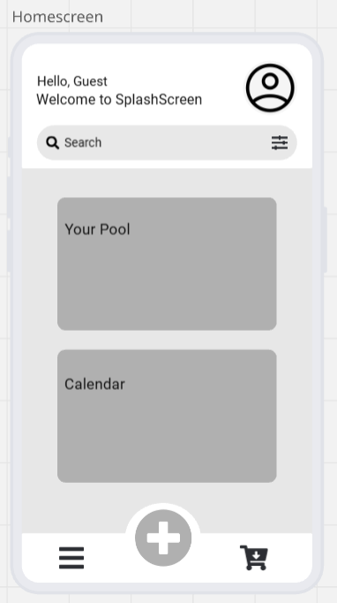
Figure 2.5 - Client Home screen
- User Greeting Section
  - Here is a personalized welcome message that greets the user.
  - If the user is not logged in, or has not made an account yet, it defaults to “Guest.”
  - Includes a profile icon, which users can tap to view or edit their profile, settings, or logout.
- Search Bar with Filter Option
  - Allows users to quickly search for services, products, or pool-related information.
  - Includes a filter icon which enables advanced search, like by service type, provider, or product category.
- “Your Pool” Section
  - Provides access to personalized pool data such as water quality, maintenance history, and settings.
  - Acts as a quick entry point to manage their pool-related data.
- Calendar Section
  - Gives users an overview of scheduled pool maintenance, service bookings, or reminders.
  - Helps users stay organized and keep track of upcoming tasks or appointments.
- Bottom Navigation Bar
  - Menu Icon (left): Tapping on this icon will open the main navigation menu for accessing app features.
  - Add (+) Icon (centre): By tapping on this quick action button to add new events, like perform maintenance, add a pool, add a note, add chemicals, add a new water reading, or use the calculator.
  - Shopping Cart Icon (right): By tapping on this icon it will direct users to the in-app marketplace where they can view or order pool-related products or services.

Client Menu Screen

The menu screen slides in from the left after the user had tapped on the menu icon in the homescreen. It gives the user centralized navigation to all key features and support options within the SplashScreen application.
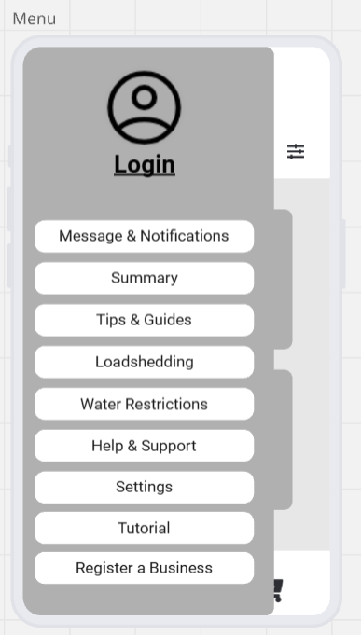
- User Profile / Login Section
  - Displays the user’s profile picture or a placeholder icon if the user has yet to upload a picture or sign in or log in.
  - Beneath the picture it shows the user’s name if logged in, or “Login” if not authenticated.
  - Provides quick access to login or account management.
- Message & Notifications
  - Will display alerts, updates, or reminders related to the user’s pool, services, purchases, or messages.
- Summary
  - This screen will provide a quick overview of the user’s pool statistics and recent activities.
- Tips & Guides
  - Offers educational content, how-to articles, and maintenance best practices for the user to learn how to maintain their pool.
- Loadshedding
  - Displays loadshedding schedules or alerts about power outages affecting pool equipment operation.
  - This will help the user adjust maintenance schedules accordingly.
- Water Restrictions
  - Displays updates on municipal or regional water usage restrictions.
Figure 2.6 Client Menu Screen
- Help & Support
  - Directs user to FAQs and troubleshooting guides.
  - This function ensures that the user can easily resolve issues.
- Settings
  - Allows users to configure preferences like notifications, language, theme, and other app settings.
- Tutorial
  - This will provide the user with an interactive guide on how the app works.
  - Can be replayed anytime for a refresher.
- Register a Business
- This will redirect the user to the “Register Your Business” screen for service providers who want to onboard their business.

The “+” Button

When the user taps on the “+” button on the home screen, the following panel expands to display shortcuts to frequently used functions. It provides the user with a fast and convenient way to perform key pool-related tasks without navigating through multiple menus.
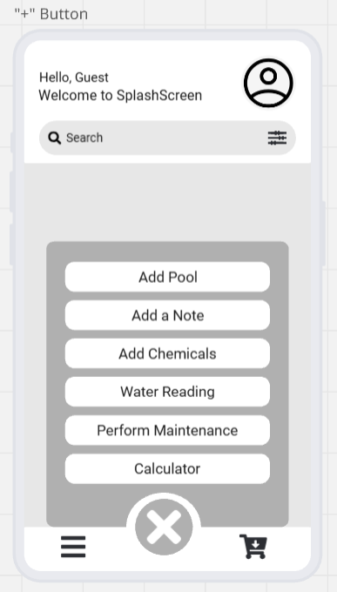
- Add Pool
  - This function allows the user to add and set up a new pool in the system.
  - The user will be able to input details such as pool name, size, and type for monitoring and maintenance.
- Add a Note
  - For the user to quickly jot down notes related to pool maintenance or water checks.
  - The notes are saved for personal records or shared with service providers.
- Add Chemicals
  - Provides the user with an interface to log chemical usage like chlorine and pH balancers.
  - This function will help keep track of chemical inventory and ensure accurate pool care history.
- Water Reading
  - This function allows the user to record water quality measurements such as pH, chlorine levels, and temperature.
  - The data logged is stored in the system for monitoring trends and generating reports.
- Perform Maintenance
  - This function guides the user through scheduling or logging maintenance tasks like cleaning, filter checks, and pump servicing.
  - This can also be linked with the calendar to remind users of upcoming or overdue tasks.
Figure 2.7 - "+" Button
- Calculator
  - This is a built-in calculator to help the user determine the correct quantity of chemicals based on pool size and water readings which the user had logged.
  - This function helps to ensure that the user gives precise chemicals for balancing, reducing wastage and improving pool health.
- Close Button (X)
  - For the user to exit the quick action panel and return to the home screen.

Client Marketplace Screen

After the user had tapped on the shopping cart icon in the home screen they will be redirected to the marketplace screen. This screen allows the user to browse, compare, and order pool-related services and products directly through the app. It connects pool owners with businesses and service providers in their area, making pool care more convenient and accessible.
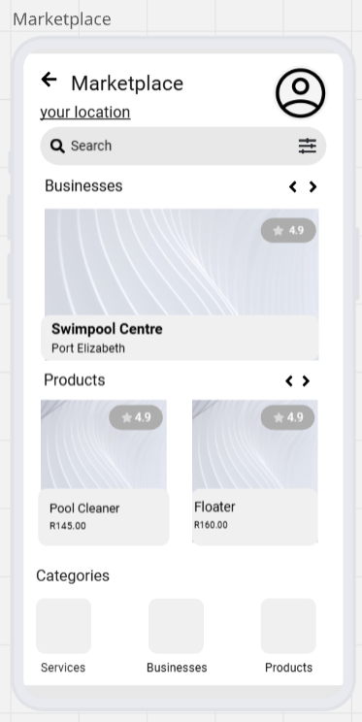
- Location-Based Listings
Figure 2.8 Client Marketplace Screen
  - In the marketplace there is a location field, “your location”, which allows the user to view businesses and products relevant to their city or region.
- Search Bar with Filters
  - Allows the user to search for specific services, businesses, or products.
  - The filter icon allows advanced sorting like by price, rating, or category.
- Businesses Section
  - This part showcases local pool businesses and service providers, like SwimPool Centre.
  - It includes key details such as their location and rating.
  - The user can click on a business to view its profile, offered services, and contact details.
- Products Section
  - This part displays pool related products, like Pool Cleaner and Floater, with prices and ratings.
  - The user can view product details and compare options.
- Categories Section
  - A quick-access navigation tiles for Services, Businesses, and Products.
  - This allows the user to filter the marketplace by type of offering.
- Profile Icon (top right)
  - Gives quick access to the users account details, order history, and preferences.

Client Profile

The clients profile screen gives a personalized overview of their account details and access to key account management settings. It ensures users can manage their identity, security, and support options within the app.

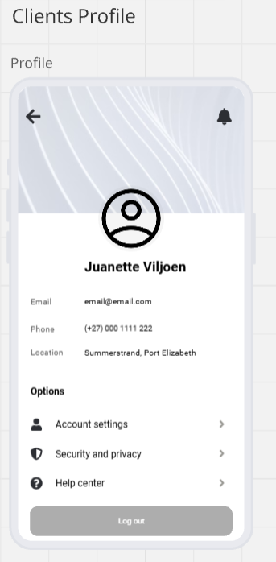
Figure 2.9 Client Profile
- Profile Information Display
  - Displays the user’s photo, name, email address, phone number, and location.
  - The user can update or change their information via the Account Settings option.
- Navigation Controls
  - Back Arrow (top left): This will return the user to the previous screen being the homescreen.
  - Notification Bell (top right): This is a quick access to alerts, updates, or important messages.
- Options Section
  - Account Settings: Tapping on the arrow will take the user to a screen that allows them to edit their personal details like their profile photo, name, contact info, and address.
  - Security and Privacy: For the user to update their password and adjust data privacy settings. This ensures the users sensitive personal information is protected.
  - Help Centre: Provides the user with quick access to FAQs and support guides.
- Log Out Button
  - Tapping this button will securely log the user out of the application.
  - This helps protect the account, especially on shared or public devices.

Business Owner Home screen

For the business owner, the homescreen will look slightly different compared to the clients homescreen. This screen provides pool service providers with tools to manage their profile, clients, and service schedules.
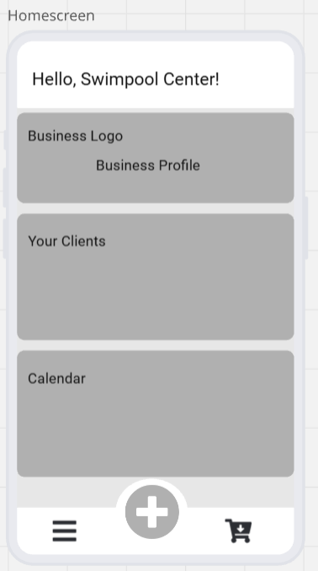
Figure 2.10 Business Owner Home screen
- Welcome Message & Business Identity
  - The header displays a personalized greeting with the business name.
  - Businesses can upload their logo and manage their professional identity.
- Business Profile Section
  - Business owners can access to edit and update their profile.
  - Includes details such as business name, description, services offered, contact details, and operating hours.
- Your Clients Section
  - This section displays a list of clients who have connected with the business through the app.
  - This will allow business owners to track client details, service history, and communication.
  - It will help businesses manage ongoing and upcoming jobs.
- Calendar Section
  - A scheduling tool for managing service appointments, bookings, and deadlines.
  - Businesses can log maintenance visits, chemical deliveries, or other service commitments.
  - The calendar syncs with notifications to remind business owners of tasks.
- Navigation Bar:
  - Menu (☰): Provides access to a list of functions like settings, tutorials, and additional business tools.
  - Quick Actions (+): Opens a shortcut to functions like adding clients, adding a note, adding chemicals, logging water readings, performing maintenance work, or to use the chemical calculator.
  - Marketplace (🛒): Allows the business owner to browse or list products/services for clients to order.

Business Owner Menu Screen

After the user had clicked on the menu icon in the homescreen the menu bar will slide open from the left. The menu bar provides quick access to key features and settings that help pool service providers manage their business operations, app usage, and account preferences.
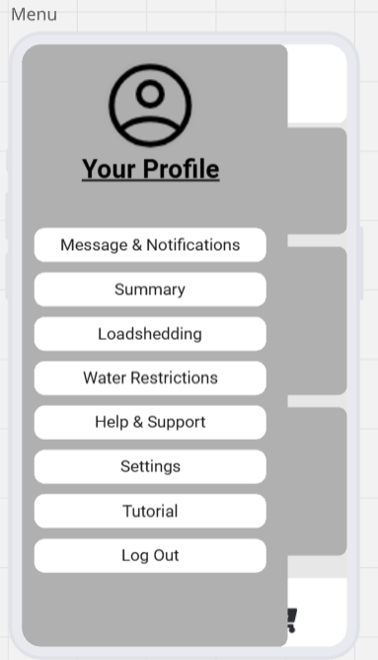
- Profile Section
  - Shows a profile placeholder with the label “Your Profile”, it will be replaced by the businesses name. The user can tap to view or edit their personal and business details.
  - This serves as a shortcut to the profile management screen.
- Menu Options
  - Messages & Notifications: This will display customer inquiries, booking confirmations, reminders, and system updates.
  - Summary: Tapping on summary will display an overview of business activity such as completed services, pending jobs, or revenue reports.
  - Loadshedding: Helps business owners by informing them of scheduled power outages, helping them plan appointments around downtime.
  - Water Restrictions: Provides updates on municipal water usage restrictions.
  - Help & Support: Will connect user to FAQs or troubleshooting resources.
  - Settings: When the user would like to access settings like customization of business preferences, notification settings, and application configurations.
Figure 2.11 Business Owner Menu
  - Tutorial: Gives access to an in-app tutorial to guide users on how to use the platform effectively.
  - Log Out: Securely logs the business owner out of the system.

The Business Owner “+” Button

After clicking on the “+” button on the bottom of the homescreen, this quick action panel will appear which provides the user with fast access to essential operational tools, making it easier to manage clients, record work, and log pool maintenance activities on the go.
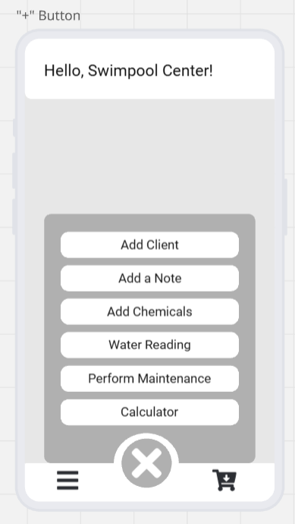
Figure 2.12 The Business Owner "+" Button
- Add Client
  - Allows the business owner to add a new client to their client list.
  - Will capture details such as name, contact info, address, and pool specifications.
- Add a Note
  - For quick entry of service-related notes or reminders.
  - Useful for recording client requests, job details, or follow-up actions.
- Add Chemicals
  - To log chemicals used during pool service visits.
  - Good for ensuring accurate billing or reporting.
- Water Reading
  - To record water quality readings such as pH, chlorine levels, and alkalinity.
- Perform Maintenance
  - To record maintenance activities performed at a client’s pool like cleaning, repairs, or equipment servicing.
  - This will also update the client’s service history for tracking and accountability.
- Calculator
  - A built-in calculator tool for quick pool-related calculations like chemical dosages.

Business Owner Marketplace

For the business owner the marketplace will look slightly different, it enables the user to showcase their services and products, while also allowing them to browse and manage listings. It acts as a digital storefront where businesses can advertise and promote their offerings to clients.

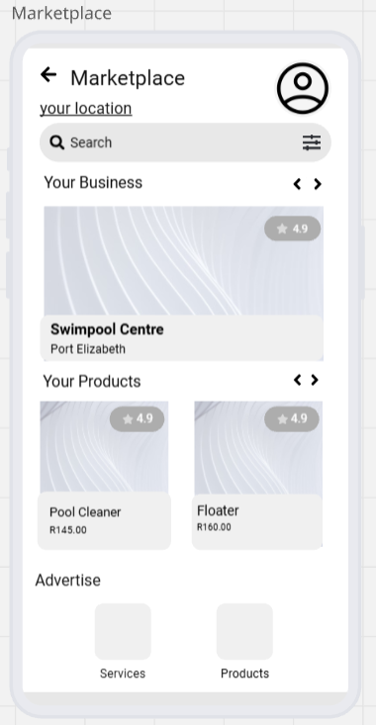
Figure 2.13 Business Owners Marketplace Screen
- Search & Filter Options
  - Allows the business user to search for specific services, businesses, or products.
  - The filter icon allows advanced sorting like by price, rating, or category.
- Your Business Section
  - Showcases the business owner’s registered profile in the marketplace.
  - It also includes a rating system to reflect customer reviews and trustworthiness.
  - Serves as a quick preview of the business listing that clients will see.
- Your Products Section
  - Displays the list of products uploaded by the business.
  - Each product shows its image, name, price, and rating, which helps clients make informed decisions.
  - Businesses can update or add new products to this section.
- Advertise Section
  - Gives the options for the business owner to advertise services or products.
- Profile Icon
  - Quick access for the businesses profile and settings. To update personal or business details while navigating the marketplace.

1.10 Annexure

Figure 1.1: High-level use case diagram ………………………………………………………………………..….10.
Figure 1.2: Unified Modelling Language class diagram………………………………………………………11.
Figure 1.3: Connection between Pool and Load shedding schedule………………………….…...…12.
Figure 1.4: Connection between Booking and Service…………………………………………….…………12.
Figure 1.5: Aggregation Connection…………………………………………………………………….…………….12.
Figure 1.6: Connection between Pool owner and pool………………………………………………………13.
Figure 1.7: Composition connection………………………………………………………………………………….13.
Figure 1.8: Connection between User and pool owner……………….…………………………………….13.
Figure 1.9: Inheritance connection…………………………………………………………………………………...13.
Figure 1.10: Entity Relational Diagram………………………………….….……………………………………….15.
Figure 1.11: Relationship between User and Pool owner…….…………………………………………….15.
Figure 1.12: One-to-one relationship………………………………………………………….…...……………….15.
Figure 1.13: Relationship between Pool owner and pool………………….……………………………….16.
Figure 1.14: One-to-many relationship…………………….….…………………………………………………….16.
Figure 1.15: Relationship between Booking and Service…………………….….………………………….16.
Figure 2.1: Login Screen…………………………………………………………………………………………………….17.
Figure 2.2: Error Message………………………………………………………………………………………………….17.
Figure 2.3: Sign Up Screen……………………………………………………..………………………………………….18.
Figure 2.4: Business Registration Screen…..……………………………………………………………………….19.
Figure 2.5: Client Home screen………..…………………….………………………………………………………….20.
Figure 2.6: Client Menu Screen………………………………………………………………………………………….21.
Figure 2.7: "+" Button……………………………………………………….……………………………………………….22.
Figure 2.8: Client Marketplace Screen……………………………………………………………………………….23.
Figure 2.9: Client Profile…………………………………………………………………………………………………….24.
Figure 2.10: Business Owner Home screen……………..……..………………………………………………….25.
Figure 2.11: Business Owner Menu…………………..……………………………………………………………….26.
Figure 2.12: The Business Owner "+" Button…………………….……………………………………………….27.
Figure 2.13: Business Owners Marketplace Screen.…….…………………………………………………….28.

